Classwork – November 18, 2008

Answer to HW on using 2 global variables to store the sum of numbers entered by the user, as well as, to store the number of numbers entered by the user. Then define two functions; one to calculate the sum of the number and count the number of numbers and the other to calculate and print the average.

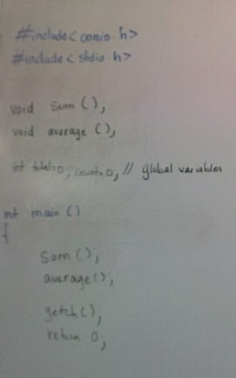

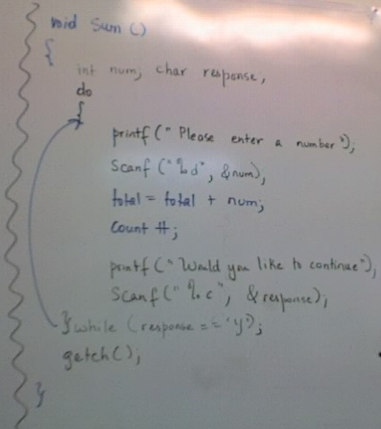
A do-while was used so that the user could at least enter one number.

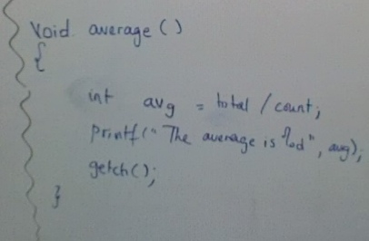
The while would look just as how you know it, the example is below.

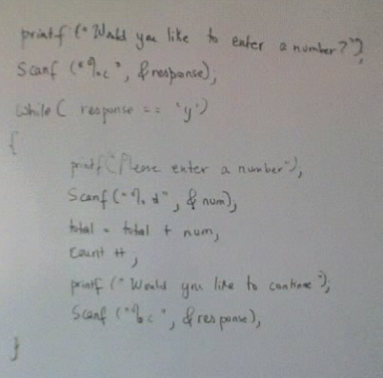

Discussion on Context Level Diagram

